Temporal analysis of Daily Precipitation Extremes at Four New Jersey Stations

Joey Fogarty

1. **Introduction**

This study examines historic daily precipitation records at four New Jersey weather stations. Starting in the flagship COOP weather observation station of NJ, the Rutgers New Brunswick Station, and looking at other long-running stations, we can analyze both precipitation extremes and higher frequency precipitation events in NJ.

The motivation for this study arose from a figure in the 2014 National Climate Assessment (NCA) was published with the following figure (Figure 1), showing that in the northeastern United States, there has been a 71% increase in “very heavy precipitation,” meaning the top 1% of each year. This figure was first published in 2009 by Karl et. al in *Global Climate Change Impacts in the United States: A State of Knowledge Report from the U.S. Global Change Research Program*. The figure below was taken from this report, and updated to include the years up to 2012. Mainly, this figure has been the motivation for looking at different methods of measuring changes in very heavy precipitation.

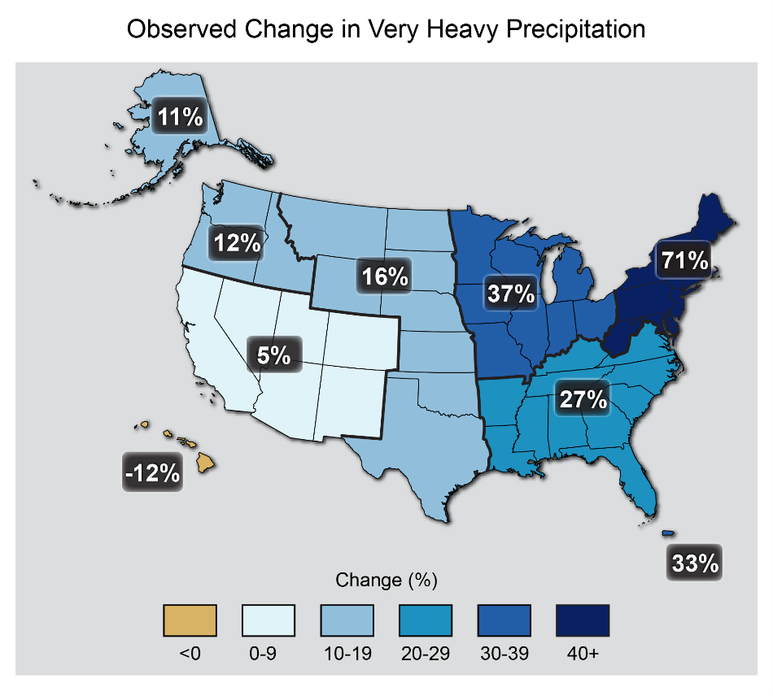

Figure 1: “The map shows percent increases in the amount of precipitation falling in very heavy events (defined as the heaviest 1% of all daily events) from 1958 to 2012 for each region of the continental United States. These trends are larger than natural variations for the Northeast, Midwest, Puerto Rico, Southeast, Great Plains, and Alaska. The trends are not larger than natural variations for the Southwest, Hawai‘i, and the Northwest. The changes shown in this figure are calculated from the beginning and end points of the trends for 1958 to 2012. (Figure source: updated from Karl et al. 2009).”

While this figure may be informative, the issue is that it is too general. Large regions of the United States are generalized into one region, which leads to stark contrasts across the boundaries of some regions. Most notably, there is a large difference in percent increase between the Virginia and Maryland border, which is likely not the case in reality. Part of this study is to determine whether trends in NJ precipitation are close to the regional average of 71%.

There are many different ways to examine and categorize extreme precipitation. The Climate Science Special Report (USGCRP 2017) published the following graphic on page 20 of the report, with four different methods for measuring extreme precipitation.

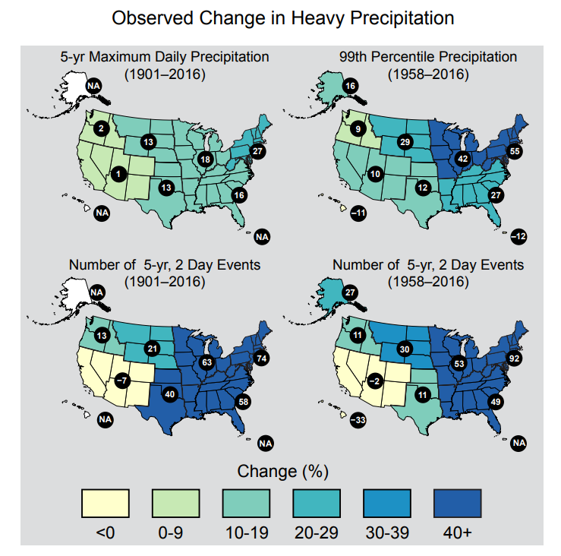

Figure 2: “These maps show the percentage change in several metrics of extreme precipitation by NCA4 region, including (upper left) the maximum daily precipitation in consecutive 5-year periods; (upper right) the amount of precipitation falling in daily events that exceed the 99th percentile of all non-zero precipitation days (top 1% of all daily precipitation events); (lower left) the number of 2-day events with a precipitation total exceeding the largest 2-day amount that is expected to occur, on average, only once every 5 years, as calculated over 1901–2016; and (lower right) the number of 2-day events with a precipitation total exceeding the largest 2-day amount that is expected to occur, on average, only once every 5 years, as calculated over 1958–2016. The number in each black circle is the percent change over the entire period, either 1901–2016 or 1958–2016. Note that Alaska and Hawai‘i are not included in the 1901–2016 maps owing to a lack of observations in the earlier part of the 20th century. (Figure source: CICS-NC / NOAA NCEI). Based on figure 7.4 in Chapter 7.”

This leads into other questions regarding temporal changes in all kinds of precipitation, not just the extremes. Roque-Malo and Kumar (2017) have recently shown that high-frequency events, such as the common rainfall, are varying even more than the extreme events. As Roque-Malo and Kumar discuss in their paper, these non-extreme events affect ecosystem and agricultural productivity, as well as those economic systems which “depend on sustained availability of water.” These types of events are also analyzed for NJ, mainly through looking at “binned events”.

1. **Quality Control**

Reliable weather observation data over long periods of time can be difficult to find. Fortunately, the Office of the NJ State Climatologist (ONJSC) has access to many station data and records throughout NJ, ready and able to be analyzed. Table 1 shows each of the four stations that were chosen for this study, as well as their periods of record.

|  |  |
| --- | --- |
| Station | Period of Record |
| New Brunswick | 1896 – 2017 (122 years) |
| Atlantic City Marina | 1874 – 2017 (144 years) |
| Indian Mills | 1902 – 2017 (116 years) |
| Sussex | 1893 – 1899, 1905 – 2017 (120 years) |

Table 1: Periods of Record for the four stations (New Brunswick, Atlantic City Marina, Indian Mills, and Sussex) used in this study.

These stations required quality control beyond what had already been run at the N. Some stations were found to have scattered instances of multi-day accumulations (a precipitation measurement over more than one day) rather than standalone daily accumulations (a precipitation total for every 24-hours). The New Brunswick station, for example, had forty-seven cases of two-day accumulations. Since the chief goal of this study is to analyze daily precipitation data, these multi-day accumulations needed to be dealt with. For these stations, a comparative analysis was conducted with surrounding stations within a sixteen-mile radius. The ratio of “day 1” to “day 2” of these stations were applied to the multi-day value, and thus a multi-day accumulation became a consecutive single-day accumulations, without altering total precipitation. In addition to the New Brunswick adjustments (using Hightstown and Plainfield stations as surrogates), twenty four were made for Indian Mills (using Pemberton and Audubon), eighty-five for Sussex (using Newton), and nine for Atlantic City Marina (using Atlantic City Airport).

1. **Climatology of Precipitation in NJ**

It is necessary to understand the climatology of New Jersey precipitation, particularly, these stations, to determine whether there have been changes over time. Table 2 shows average annual precipitation for each station, using both the most recent 30-year average (1988-2017), as well as from the beginning of the record through until 1987. The last column shows the difference from the earlier average to the most recent 30-year average. Each station exhibits an increase in annual precipitation , indicating that these stations have seen at least some increase in precipitation in recent years.

|  |  |  |  |  |
| --- | --- | --- | --- | --- |
| **Station** | **Avg. Annual Precipitation (in.)** | | **Difference (in.)** | **Percent Increase** |
| **POR – 1987** | **1988 – 2017** |
| *New Brunswick* | 44.90 | 48.95 | +4.05 | 9.0% |
| Atlantic City Marina | 40.37 | *41.31* | +0.94 | 2.3% |
| Indian Mills | 45.78 | 48.29 | +2.51 | 5.5% |
| *Sussex* | *42.38* | 45.25 | +2.87 | 6.8% |

Table 2: Average Annual Precipitation for the 1981 – 2010 climatological period, annual precipitation for the period of record, as well as the difference between the two. Italicized values have a p-value <0.05, indicating statistical significance at the 95% confidence interval. Italicized station names have a p-value <0.05 for the entire period of record.

Time series of annual precipitation for each station can be viewed here[LINK HERE].

Annual average precipitation is one way to understand precipitation in a region, but the distribution of precipitation events is important too. Two methods were utilized throughout this study to examine the distribution of daily precipitation events, the first being the “binning events” method. By separating daily precipitation values into binned events, we can analyze any trends of these bins over time. Table 3 shows the different precipitation categories and their respective ranges.

|  |
| --- |
| Precipitation Ranges (in) |
| 0.00 – 0.02 and T |
| 0.03 – 0.10 |
| 0.11 – 0.25 |
| 0.26 – 0.50 |
| 0.51 – 1.00 |
| 1.01 – 2.00 |
| 2.01+ |

Table 3: The categories used for the “binning” method.

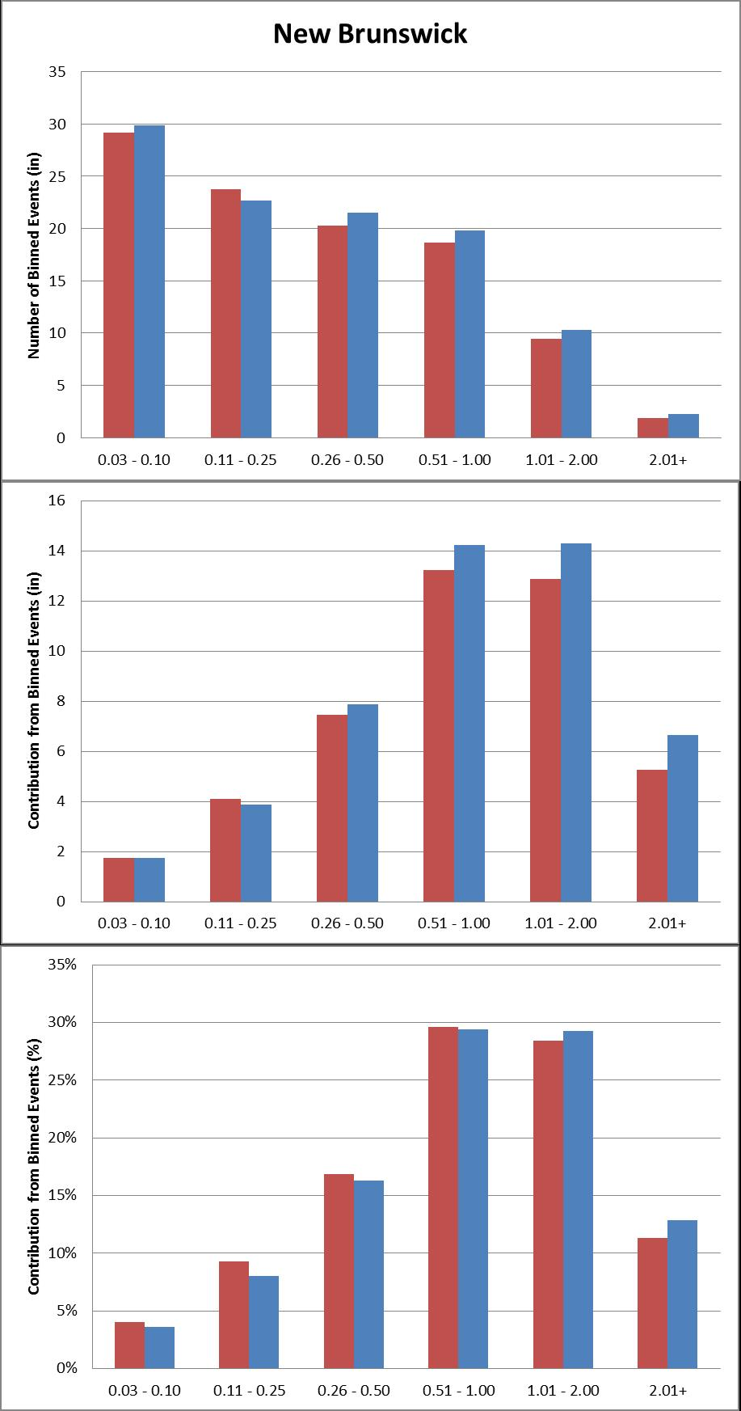The categories of 0.01” – 0.02” and trace values will be ignored throughout this study. Records of trace values are not found in digital records, and very light precipitation observations may be inconsistent due to observer biases or gauge limitations. Within this binning method, there are multiple ways to explore precipitation trends. One way is to examine the number of events that occurred in each year, and plot this as a time series. We can also look at the contribution of precipitation in each bin to annual precipitation; similarly, we can also express each contribution as a percentage of annual precipitation. Two different climatologies were used; the first being the past 30 years (1988 - 2017), and the second being the entire period of record before that (POR - 1987). This allows for a comparison of what has happened in recent years to what has happened beforehand. Figure 3 details this climatological data for New Brunswick. The information for each of the four stations can be found here [link here to binned_climo_figures.pdf] [caption].

Figure 3: a) Showing the average number of binned events for 1988 – 2017 (blue) and POR – 1987 (red) climatologies for New Brunswick; b) showing the average annual contribution of each bin with same climatologies as before; c) showing contribution from binned events expressed as a percentage of annual precipitation, with same climatologies as before.

It is important to distinguish between the number of events in a bin, and the amount of precipitation that each bin contributes to an annual total. Figure 4 shows that while there are more 0.03 – 0.10 events per year than any other type of event, the 0.51 – 2.00 group contributes more to the annual precipitation total than any other group. In other words, the average number of events steadily decreases as the bin increases in precipitation, while the same is not seen for the amount of precipitation contributed per bin.

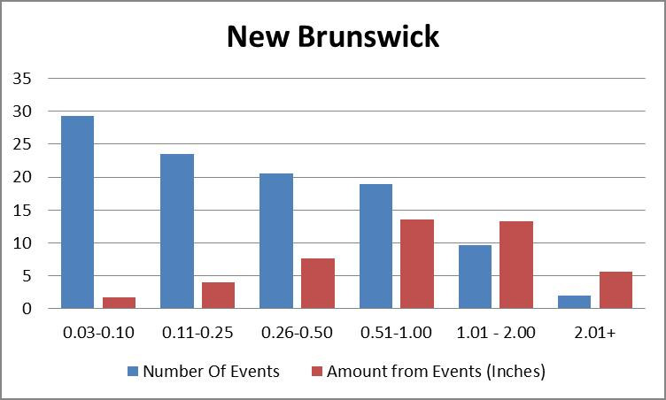

Figure 4: In blue, the average annual number of events per bin, and in red, the annual amount of precipitation from each event in red for New Brunswick (1896 - 2017). See this same plot for the other three stations here [Insert link here to avgs_figures.pdf].

1. **Changes in Extreme Precipitation**
   1. **Binned Events and Grouped Trends**

We now explore temporal aspects of daily precipitation from the late 19th and early 20th centuries to present. The three metrics described above (number of events in a year, contribution of each bin in a year, and contribution to each bin expressed as a percentage of annual precipitation) are examined for each station.

Looking at Figure 5 which shows the number of events for Indian Mills (small bins), these events are, on average, decreasing over time. In particular, the linear regression slope of -0.1339 (for the number of 0.03” – 0.10” events) means that in Indian Mills, these events are decreasing a little more than one event per decade, on average. The blue time series (not the trendline), shows that this is more pronounced in recent years, as can be seen by the steep drop off of events around 2000. Yet looking back at the annual precipitation for Indian Mills, there is a slight increase in the post-2000 annual precipitation. This can be further corroborated by noting that, in Figure 6, the number of events of the larger bins is increasing.

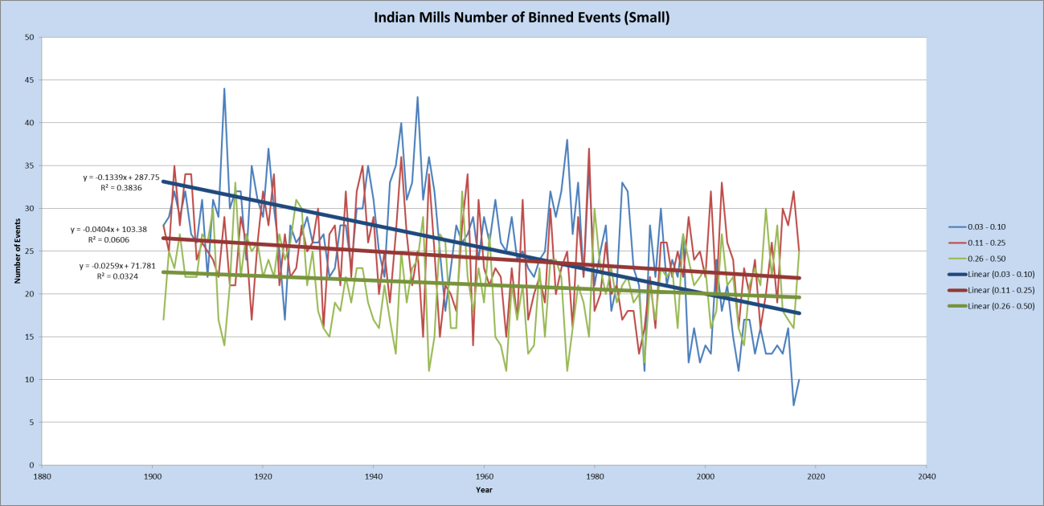

Figure 5: The number of daily precipitation events for Indian Mills, NJ, in bins from 0.03” – 0.50”

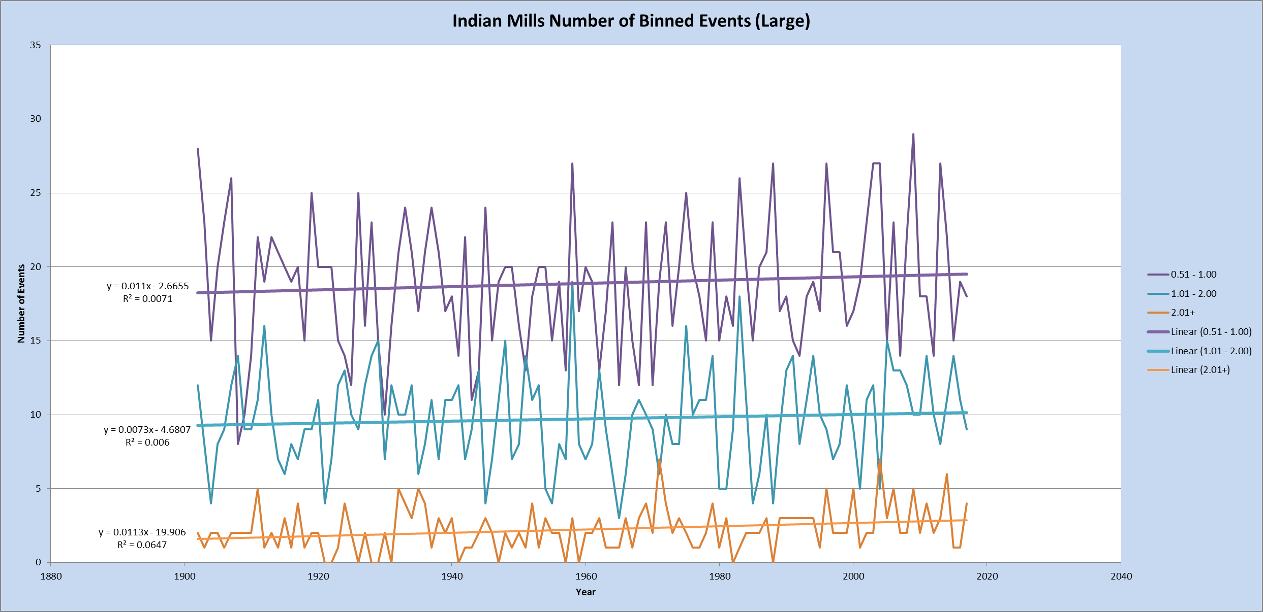

Figure 6: The number of daily precipitation events for Indian Mills, NJ, from 0.51+”

The increase/decrease relationship seen in Indian Mills can be seen in Atlantic City Marina (ACM) plots (consult the appendix at the end to see similar figures for ACM). What ACM also shows is an increase of total amount of precipitation within these bins, expressed as a percentage of annual precipitation (to avoid wet/dry year bias). As shown in Figure 7, the precipitation within the four smallest bins (up to 1.00”) is contributing less overall to annual rainfall, with all curves being statistically significant except for 0.51” – 1.00”. In Figure 8, it can be seen that the percentage of precipitation within bins above 1.00” are increasing over time. Both curves show an increase over time, but only the 1.01” – 2.00” curve showed statistical significance.

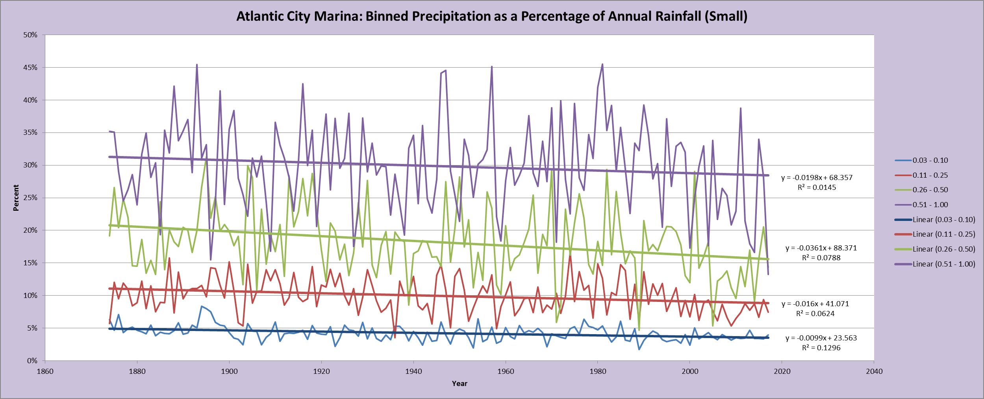

Figure 7: The amount of annual precipitation within bins 0.03” – 1.50” for Atlantic City Marina, NJ, expressed as a percentage of annual rainfall

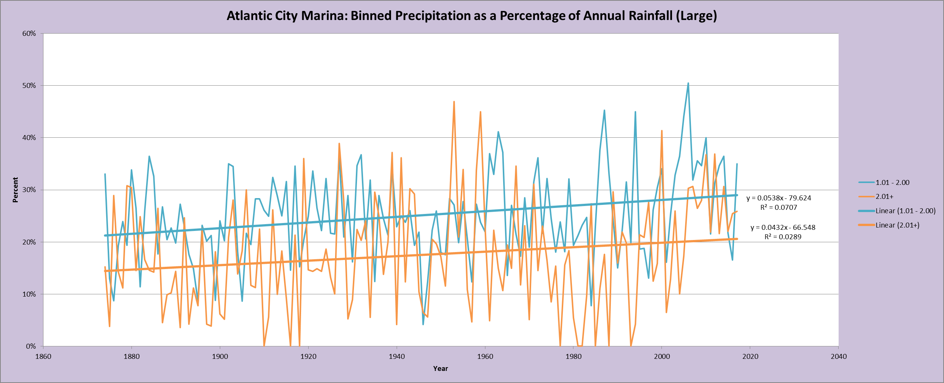

Figure 8: The amount of annual precipitation within bins 1.01+” for Atlantic City Marina, NJ, expressed as a percentage of annual rainfall

New Brunswick has a different trend than the previous two stations. Of the four stations, New Brunswick and Sussex have a statistically significant increase in annual precipitation, so the importance of expressing amounts as percentages of annual precipitation comes in handy for these stations.

Examining the amount of precipitation within the bins, the larger bins are in fact increasing in amount of precipitation. However, the figures which display precipitation within bins as a percentage of annual precipitation show a negligible increase, in part because the annual precipitation is increasing.

Sussex also presents a different story than the previous stations. As mentioned above, its annual precipitation is increasing. Similarly, all of the number of binned events is increasing; this makes sense, considering annual precipitation is increasing. What is interesting here is that in Sussex, a lot of the precipitation is coming from the 0.11” to 0.25” group – suggesting that at this station, the “middle” events are increasing the most.

For the interested reader, all plots have been provided for all four stations in the following categories: number of events of each station [link to NOBE_figures.pdf], total precipitation within bins [link to TPWB_figures.pdf], and total precipitation within bins as a percentage of annual rainfall [link toTPWBPercent_figures.pdf].

* 1. **Looking at Percentiles**

A drawback of looking at precipitation via the “binned categories” method is the lack of attention paid to extreme events, such as multiple inch events. For these extreme events, it is best to consider where they lie in terms of percentile categories, such as 90th, 95th, and 99th percentile for a given year and see if there are any trends present.

Looking at the *actual amount* of precipitation in the 90th, 95th, and 99th percentile allows us to see how much rain actually falls in these “top categories.” For example, Figure 9 below shows the amount of precipitation in these top categories for New Brunswick.

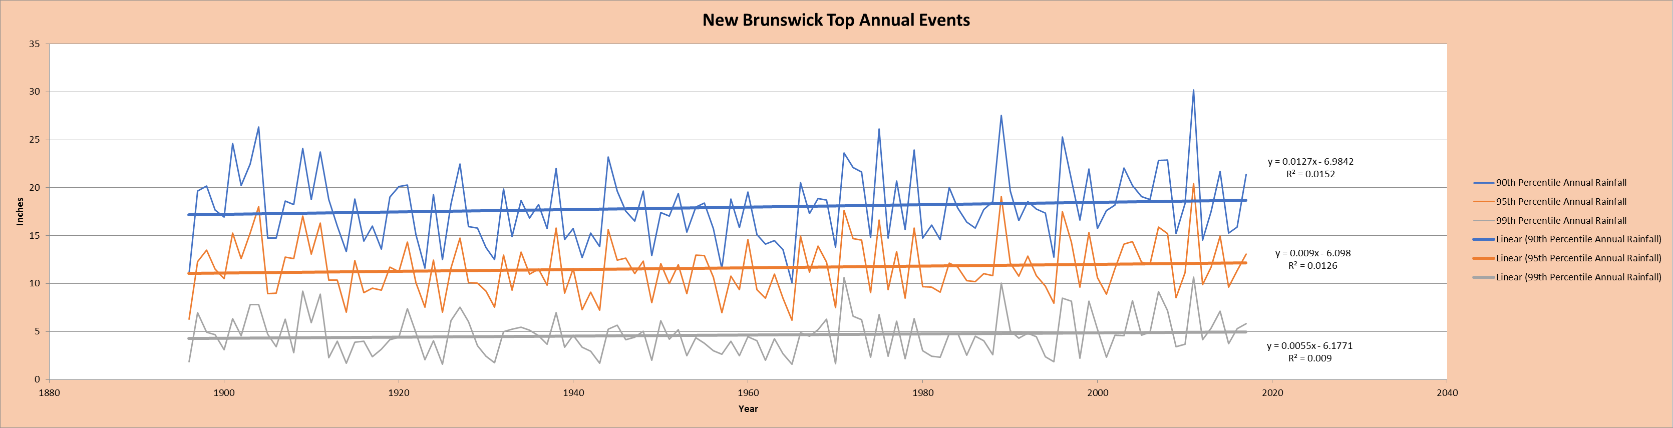

Figure 9: Amount of rainfall in the 90th, 95th, and 99th percentile of annual daily events for New Brunswick

None of the New Brunswick curves are significant, so there is almost no trend in these curves, and the slopes for the trendlines are almost negligible. Both Atlantic City Marina and Indian Mills also share this pattern. However, Sussex is a different story. Figure 10 below is the same as Figure 9, but it is for Sussex. As can be seen, there is a difference here, as all of the trendlines show a statistically significantly increase over time.

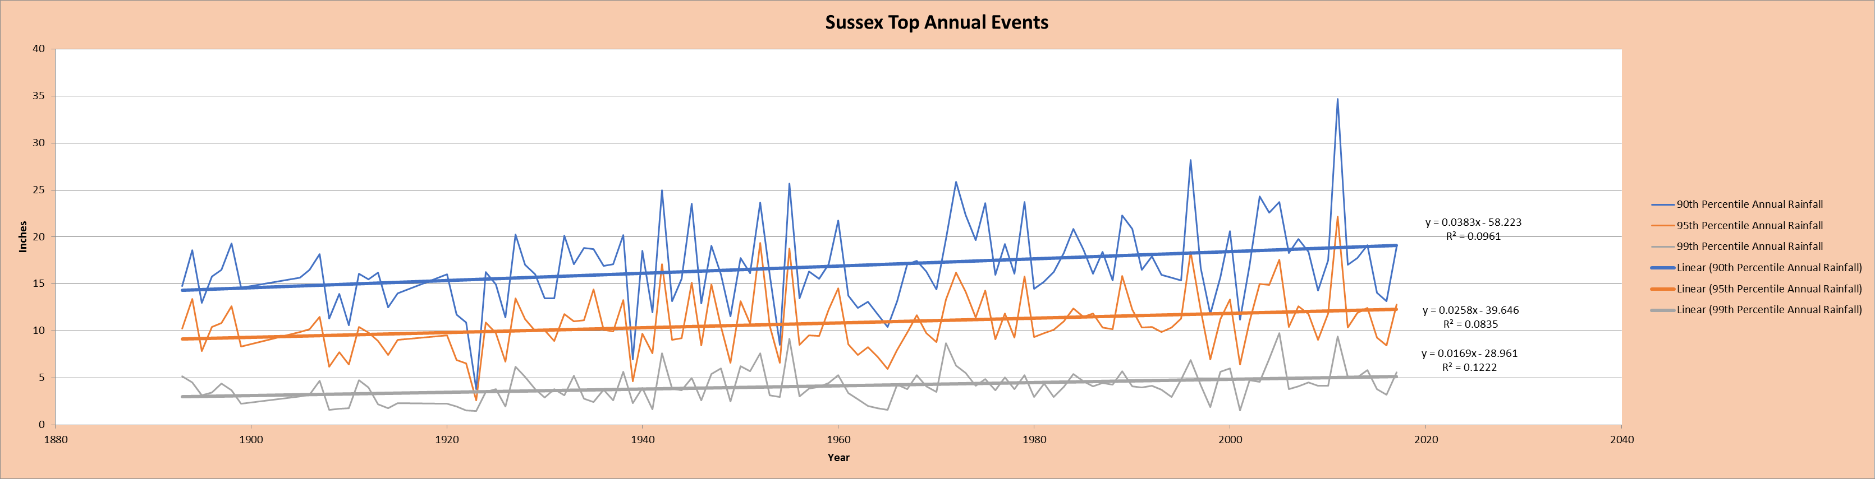

Figure 10: Amount of rainfall in the 90th, 95th, and 99th percentile of annual daily events for Sussex

Figure 11 further corroborates this, as it is the same as Figure 10 but is instead expressed as a percentage of annual rainfall. After ridding of the wet/dry year bias, there still seems to be an increase in the top 1%, 5%, and 10% of events. This means that, over time, more of the annual rainfall has fallen in larger daily events.

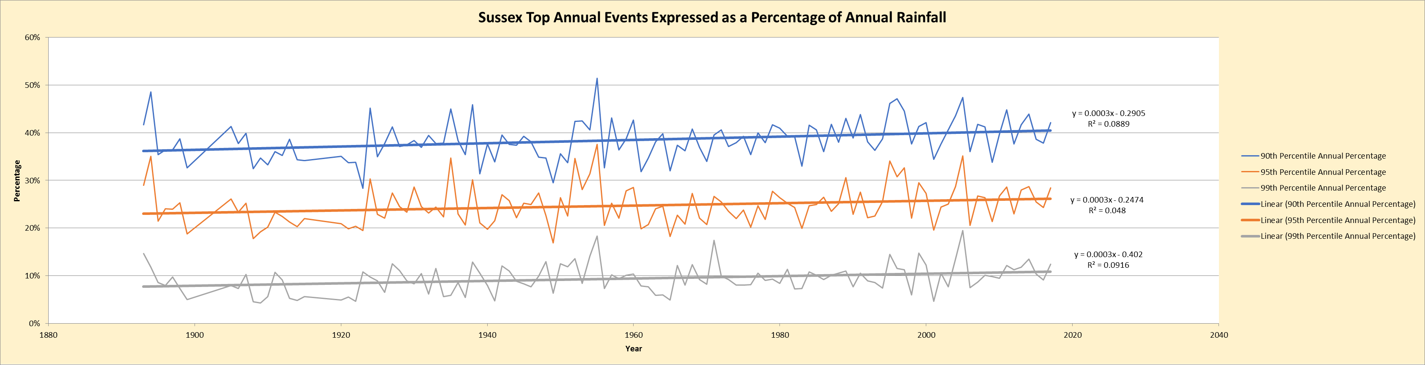

Figure 11: Amount of rainfall in the 90th, 95th, and 99th percentile of annual daily events for Sussex, expressed as a percentage of annual rainfall

Again, the interested reader can view every percentile plot for each station here [link here to percentile_annual_figures.pdf].

1. **Conclusion**

What we found, overall, is that precipitation is indeed changing, but the change in extreme precipitation is not as much as the 70% in Figure 1. Part of this was expected – that graphic covers a wide geographic area, so that 70% is an average of a multi-state region. But this study was done to get a closer look at precipitation not just in the northeast, but particularly in NJ.

The percentile plots also seem to suggest that NJ has not seen such an increase in heavier events. The northernmost station, Sussex, was the only one with a statistically significant increase in the amount of rain in the top percentiles in recent years. Other stations showed a slight decrease on average in the amount of precipitation within those percentiles. The fact that the northernmost station showed an increase in the annual top percent of events may lend itself to the geography of the area. It is possible that there will be a larger trend in the top percent of daily events north of New Jersey.

It must be said that this was a small sample size, with only four stations. Yet, we wanted to investigate further how precipitation behaved in NJ, and if there were any patterns, and the four geographically separate stations seemed to be suitable to gain some insight on NJ precipitation.

Defining precipitation is important too – and important to communicate how you define it. As shown in this study, the definition of extreme precipitation changes the conclusions that are made about it. Many methods were used to look at precipitation trends: number of binned events, amount each binned event contributed, amount in percentile events, as well as expressing all of these categories as percentages of annual totals. A recent article by Pendergrass, published in *Science* magazine, discusses this.

1. **References**

Karl, T. R., J. M. Melillo, and T. C. Peterson (eds.), 2009: Global Climate Change Impacts in the United States, 196, Cambridge University Press, <https://downloads.globalchange.gov/usimpacts/pdfs/climate-impacts-report.pdf>

Pendergrass, A. G., 2018: What precipitation is extreme?. 10.1126/science.aat1871

Roque-Malo, S., and P. Kumar, 2017: Patterns of change in high frequency precipitation variability over North America. *Scientific Reports*, **7**, 1-12.

Trenberth, K.E. and Y. Zhang, 2018: How Often Does It Really Rain?. *Bull. Amer. Meteor. Soc.,* **99**, 289–298, <https://doi.org/10.1175/BAMS-D-17-0107.1>

**USGCRP**, 2017: *Climate Science Special Report: Fourth National Climate Assessment, Volume I* [Wuebbles, D.J., D.W. Fahey, K.A. Hibbard, D.J. Dokken, B.C. Stewart, and T.K. Maycock (eds.)]. U.S. Global Change Research Program, Washington, DC, USA, 470 pp., doi: 10.7930/J0J964J6